**Automated TurnKey Virtualization Utility**

**Project Participants:** Emmanuel John, William B Thomas

**About TurnKey Linux** - The TurnKey Linux Virtual Appliance Library is an open source project developing a free virtual appliance library of pre-packaged servers based on Debian Linux (Wheezy 7.2) that can be deployed on virtual machines, in cloud computing infrastructures or installed in physical computers.

As the TurnKey Linux websites states, “Unlike with traditional software, you don't have to worry about complex OS compatibility issues, library dependencies or undesirable interactions with other applications because a virtual appliance is a self contained unit that runs directly on top of hardware or inside a virtual machine.”

The packages available for TurnKey Linux include LAMP, Joomla, Drupal, WordPress, MySQL, MediaWiki, Ruby on Rails, phpBB, OwnCloud, and many others.

(See Appendix 1 for current list)

**Synopsis:** The purpose of this project is to combine the virtualized applications provided by TurnKey Linux with a configurable GUI, which will enable the system administrator to rapidly download and install multiple instances of their chosen virtual application on a single or multiple remote virtual hosts.

We will accomplish this by utilizing Qt for the graphical user interface and python to handle the major operations of the program. The design pattern employed will be MVC in order to provide a responsive interactive process between the user and their machines.

**Tentative Screen shot**

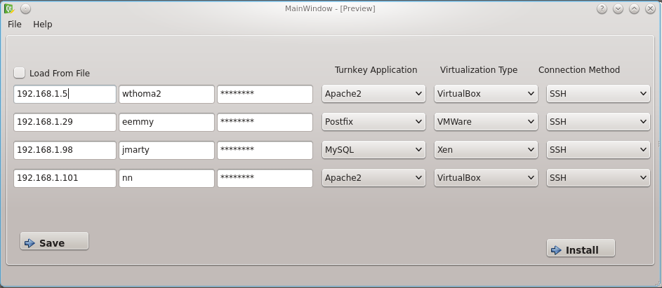

As seen in the screen shot above, the graphical user interface should be straight forward and intuitive to the user. The user supplies the machine list via file or manual entry along with appropriate credentials, selects the desired TurnKey application (which should be auto-populated from the TurnKey website on startup), the virtualization method employed on the user's system, and the connection method.

These values are subject to change in the future. The primary factor for such changes will be our ability to test the applications given the limited hardware we or Clemson University owns.

**Timeline**

* 25 February 2014 - Develop tentative GUI for Milestone 1
* **28 February 2014** – Turn in MileStone 1
* 2 March 2014 – Finish the installation of at least 5 virtual applications and begin developing the scriptable elements, noting the applications that may be outliers in relation to the scripting.
* 20 March 2014 – Finish coding all the communications methods (currently only SSH). This will be determined based on operating systems used, applications available, etc.
* 27 March 2014 – Have a working product for turn in.
* **28 March 2014 –** Turn in MileStone 2
* 29 March 2014 – Finish implementing any secondary features not already implemented
* 2 April 2014 – Continue testing of code base (Python UnitTest) as well as across host machines
* 10 April 2014 – Implement some basic documentation for the user
* **16 April 2014**  - Turn in MileStone 3

**Appendix 1** – **Full List of TurnKey Virtual Application Library**

Etherpad Lite – Real-time document collaboration

Joomla 2.5 – Cutting Edge Content Management

Drupal 7 – Content Management Framework

ASP .NET on Apache with Mod Mono – Free .NET hosting

Sahana Eden – Humanitarian Platform

Ushahidi – Crowdsourcing Crisis Information

GitLab – Self Hosted Git Management

CouchDB – JSON based Web database

LAMP Stack – Web Stack (MySQL)

Google AppEnging Go SDK – Cloud application development

Google App Engine Python SDK – Cloud development

Google AppEngine Java SDK – Cloud application development

Elgg – Social networking engine

Concrete5 – Next generation Content Management System

eZ publish – Enterprise Content Management System

e107 – Content Management System

Collabtive – GroupWare

CodeIgniter – Web application framework

AppFlower – Rapid Business Application Framework

b2evolution – Content management system

BambooInvoice – Simple, Beatiful Online Invoicing

MongoDB – NoSQL database

Mibew – Live Support Chat

Nginx PHP FastCGI Server Configuration – with PHPMyAdmin

Clipbucket – Video sharing

Canvas – Learning Management System

CakePHP – Rapid development PHP framework

node.js – Asynchronous Javascript Framework

iceScrum – Agile collaborative development

Jenkins – Continuous integration

Mambo – Content Management System

Mahara – Electronic portfolio and social networking

Lighttpd PHP FastCGI Configuration – with PHPMyAdmin

OpenLDAP – Open Source Directory Services

osCommerce – Online Shop

Omeka – Serious web publishing for cultural collections

Plone – Open Source Content Management

LimeSurvey – Survey applications

OrageHRM – Human Resources management

OpenPhoto – All your photos in one spot

Piwik – Real Time Web Analytics

Pligg – Social publishing CMS

SilverStripe – CMS and framework

PunBB – Forum software

ProcessMaker – Workflow & BPM software

Sencha – Framework for Mobile HTML5 webapps

OSQA – QA system

ownCloud – Share files, music, calendar

phpList – Email campaign management

PHP-Nuke – Content Management System

Vanilla forum – Community forums evolved

web2py – Python framework

Phreedom – Enterprise Resource Planning

Typo3 – Enterprise CMS

TomatoCart – Shopping Cart

XOOPS – Content Management and Web Application Platform

Zurmo – Gamified, Social, Mobile CRM system

SiT! Support Incident Tracker – Support incident tracker

SimpleInvoices – Invoicing system

SimpleMachines – Forum system

SugarCRM – Business & Social CRM software

Zen Cart – online store management system

Yii Framework – PHP framework

Ruby on Rails – Web application Framework

File Server – Simple Network Attached Storage

WordPress – Blog Publishing Platform

Redmine – Integrated SCM & Project Management

OTRS – Ticket Request System

MediaWiki – Wikipedia's Wiki Engine

PrestaShop – Easy to use online shop

LAPP – Web Stack (PostgreSQL)

Magento – Flexible eCommerce Platform

PostgreSQL – Object-relational Database System

Django – High-level Python Web Framework

LXC – Lightweight Linux Containers

Observium – Network Management and Monitoring

Tendenci – Content Management System for Non-Profits

OpenVPN – Open Source VPN solution

TKLDev – Appliance Development Toolchain and Build System

MySQL – Relational Database Management System

phpBB – Community Forum Solution

Tomcat on Apache – Java Servlet and JSP Platform

Standalone Tomcat – Java Servlet and JSP Platform

MinTouch Core – Enterprise Wiki

Tracks – Getting Things Done (GTD) Application

Symfony – PHP Web Framework

ProjectPier – Easy Online Collaboration

ejabberd – XMPP and Web Chat

TurnKey Core – Common Base for all Applicances

Twiki – Enterprise Wiki Platform

Domain Controller – Drop-in PDC replacement

Revision Control – All-in-one code repository

Torrent Server – File download and sharing server

Bugzilla – Bug Tracking System

Gallery – Photo Album Organizer

Moodle – Course Management System

Mantis – Bug Tracking System

Movable Type – Professional Publishing Platform

vTiger CRM – Customer Relationship Management

StatusNet – Open, distributed microblogging

MoinMoin – Wiki Engine

Roundup – Issue Tracking System

Trac – Integrated SCM & Project Management

DokuWiki – Documentation Wiki Platform

Drupal 6 – Content Management Framework

Joomla 1.5 Appliance – Cutting Edge Content Management